Latchmere Academy Trust Climate Action Plan
Please be aware this CAP is a working document.
At Latchmere Academy Trust, we are committed to educating and inspiring our pupils and stakeholders about environmental concerns and the importance of living sustainably.
Our aim is to reduce our carbon emissions by 78% by 2035 and to be net zero by 2050.
Net Zero means 90% reduction in scope 1, 2, 3 emissions and the last 10% can be neutralised using carbon removal offsets, e.g. planting trees, improving biodiversity.
LAT values support the aims of our climate action plan.
Ambitious | We set bold and inspiring sustainability goals, encouraging students to think big and take meaningful action to reduce the school’s carbon footprint.
Individual Child | Every child is empowered to make eco-friendly choices, from reducing waste to leading their own mini-projects that contribute to a greener school.
Collaborative | Our stakeholders work together and with experts on initiatives like school gardens, recycling programs, and energy-saving campaigns to create a lasting impact.
Resilient | We encourage perseverance by learning from challenges, adapting our strategies, and continuously improving our climate actions despite obstacles.
Inclusive | Our climate initiatives ensure that every child, regardless of background or ability, has a voice and a role in making our school more sustainable.

Our Climate Action Team
Trustee/ governor: Mary Parker
Executive Team: Anna Steels (Executive Head) Adele Rowe (CFO)
Nelson staff:  Amy Bond (Class Teacher)  Lucia Lopez (Class Teacher)  Caroline Duncan (Teaching Assistant) | Latchmere staff:  Helen Luck (Class Teacher)  Rhianon Board (Class Teacher)  Zoe Regan (Class Teacher)  Jack Hanrahan (Site team)

Current Picture
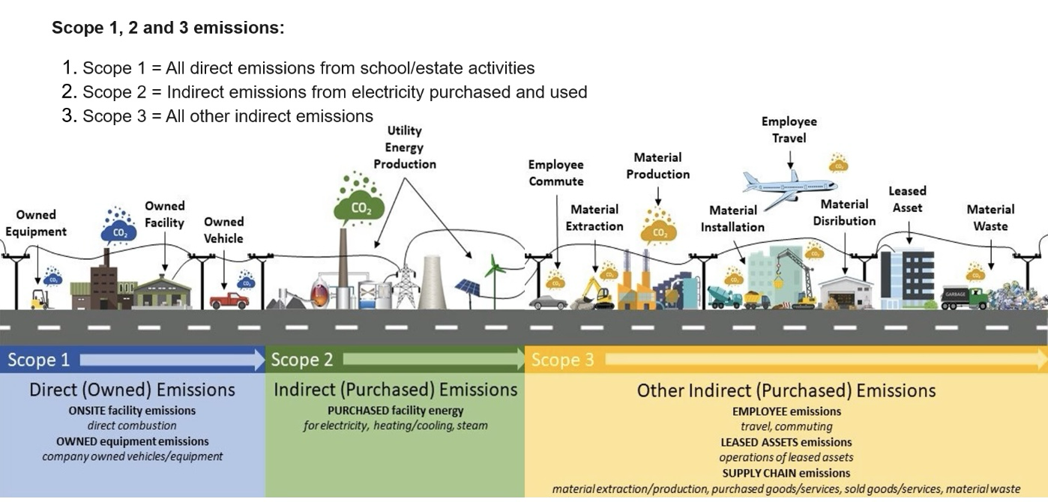
  - Carbon Emissions Scope 1 and 2

School | Scope | Greenhouse Emission Activities (kWh per year) | Total Emissions (tCO2e) | Emissions per pupil (tCO2e per pupil) | Emissions per m2 (tCO2e per m2)
Latchmere | Scope 1  (Gas) | 544594 | 99.606 | 0.137 | 0.025
 | Scope 2  (Electricity) | 294135 | 60.901 | 0.084 | 0.015
Nelson | Scope 1  (Gas) | 436927 | 79.914 | 0.328 | 0.023
 | Scope 2  (Electricity) | 206075 | 42.668 | 0.175 | 0.012

Lighting Scope 2
 | Latchmere | Nelson
Annual kWH | 115,179 | 128,859
Annual tCO2e | 23.847 | 26.68
Annual tCO2e per pupil | 0.026 | 0.11

  - Water Consumption Scope 3
Nelson’s water consumption and waste appears extremely low. This may be due to being in credit on the account and bills being produced twice a year.
Latchmere have a swimming pool which needs regular partial and annual total emptying and refilling to protect against legionella. Bills are produced monthly.

 | Latchmere | Nelson | Benchmark data
Consumption Litres/ day | 11,378.1 | 2,030.1 | 4,496
Waste Litres/day | 9,791.8 | 1958.9
Consumption Litres/ day per pupil | 11.69 | 8.32 | 12.69
Waste Litres/ day per pupil | 10.06 | 8.03
CO2 emissions annual | 0.64tCO2e | 0.11tCO2e

  - Waste
LATs waste will be calculated during the Summer Term 2025 to provide a baseline.

  - Travel Plans and Initiatives
Travel surveys will take place at both school in Autumn 2025 to create a baseline.

Local Areas Climate Assessment

  - Flood Risk https://check-long-term-flood-risk.service.gov.uk/search?postcode
 | Surface Flooding  2025 | Surface Flooding 2040-2060 | River and Sea  2025 | River and Sea  2040-2060 | Ground water 2025 | Ground water 2040-2060 | Reservoir  2025 | Reservoir  2040-2060
Latchmere | Low  Low chance 20cm+ | Medium  Low chance 20cm+ | Very low | Very low | Unlikely | Unlikely | Unlikely | Unlikely
Nelson | Very low  Very low 20cm+ | Very low  Very low 20cm+ | Very low | Very low | Unlikely | Unlikely | Unlikely | Unlikely

  - Weather Risks
The following table shows the impact weather could have on the local areas of schools which are part of the Latchmere Academy Trust (by postcode).
It identifies the hottest day temperature in °C and wettest days rainfall in mm (from 1991-2019) alongside the impact of a 2°C or 4°C increase in temperature due to global warming.
 | Hottest Days |  |  |  |  |  | Wettest Days
 | Temperature °C |  |  | Number of days above 25°C |  |  | Rainfall in mm |  |  | Number of Rainy Days per month
 | 2025 | +2°C | +4°C | 2025 | +2°C | +4°C | 2025 | +2°C | +4°C | 2025 | +2°C | +4°C
Latchmere Summer | 37 | 38.7 | 43.1 | 6 | 11 | 21 | 42 | 54 | 52 | 8 | 7 | 4
Latchmere Winter | 19.9 | 20.4 | 21.8 | 6 | 11 | 21 | 35 | 33 | 49 | 10 | 10 | 10
Nelson Summer | 36.7 | 38.7 | 43.3 | 6 | 11 | 20 | 41 | 54 | 50 | 8 | 7 | 5
Nelson Winter | 19.9 | 20.4 | 21.6 | 6 | 11 | 20 | 33 | 33 | 44 | 10 | 10 | 10

  - Air Quality
The schools in Latchmere Academy Trust are within 15 miles of Heathrow Airport which significantly impacts the air quality of the surrounding local area and is considered a major source of air pollution in the region, primarily due to aircraft emissions which contribute to high levels of nitrogen dioxide (NO2) and particulate matter.

Latchmere School Air London Pollution Information 2025 | Nelson Primary School Air Pollution Information 2025
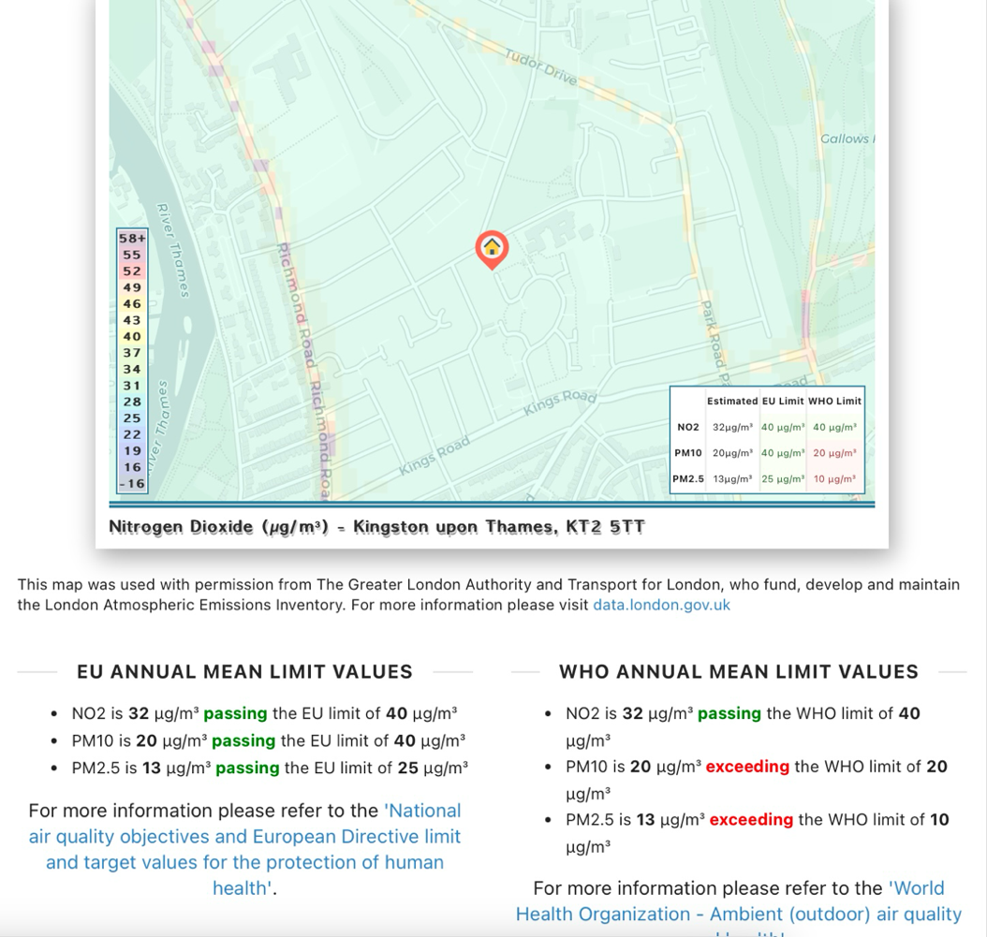 | 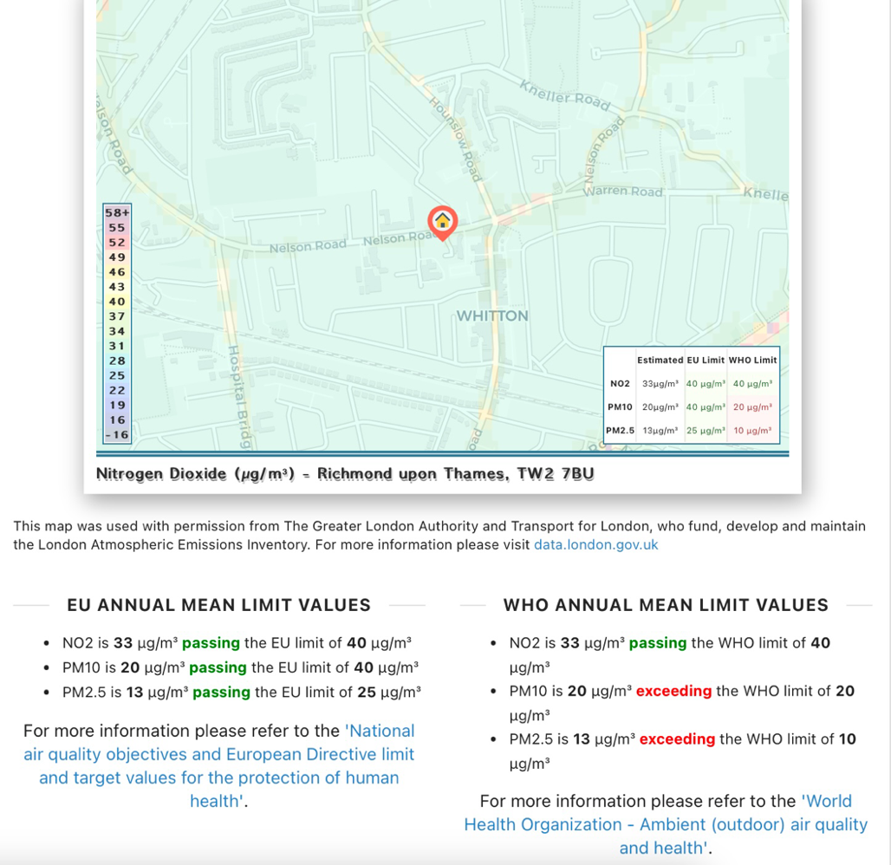

Biodiversity and Green Infrastructure
Both schools have recently commissioned a Journey to Decarbonisation Energy Report to support the trust in identifying how the schools could be more energy efficient.
Due to the reduction of pupils applying for reception places nationally, both schools within the trust have experienced a falling roll and therefore have additional space available. Consideration has been given as to how the trust can ensure the optimal use of space and we are currently in conversation with the local authority about this.
Nelson Stage1 JTD Report.pdf

Latchmere Stage1 JTD Energy Report.pdf

Climate Education
We are currently auditing our curriculum to see how and where we are raising awareness and developing children’s knowledge and skills related to climate resilience.

Risk Assessment and Mitigation

Type of risk | Risk and impact details | Likelihood Occurring (1=Low, 5= High) | Impact Occurs (1=Low, 5 = High) | Total Risk Score | Mitigation & Control Procedure | Residual Risk Rating
Flooding | Surface flash flooding, river and sea, groundwater and reservoir flooding have increased due to global warming. If schools flood, there is a likelyhood that they will need to close while work is completed to dry buildings, check for structural damage and redecorate. | 1 | 2 | 2 | The long term projections for flooding within the postcodes of the schools in the Latchmere Academy Trust are very low, with a slight increase of medium risk of flooding up to 20cm at Latchmere from surface water by 2040-2060. No additional actions are needed at this stage but this should continue to be monitored annually for any change. Additional consideration should be given to installing soft pour or artificial grass as this can prevent the drainage of rain water. | 1
Weather Risks | As temperatures rise due to global warming, there is an increased risk of extreem weather including the chance of heatwaves and an increase in the number of days when weather is above 25°c. Extreem heat can pose a health risk to children and adults. | 4 | 4 | 16 | Both schools should consider creating additional shaded areas on playgrounds. The installation and use of airconditioning should be considered, however this should be balanced against potential emmissions created by these systems. | 8
Air quality | Both schools exceed the World Health Organisations limit for PM10 and PM2.5. These are tiny particles of air pollution that can be inhaled and cause serious health problems. | 4 | 4 | 16 | Both schools are within 15 miles of Heathrow, with Nelson being within 6 miles. This can not be mitigated against. However, safer road schemes could be implemented locally along with anti idling campaigns. | 12
Waste

CAP Risk Register.xlsx

Action Plan 2024-2026
The long term aims of Latchmere Academy Trust is to reduce carbon emissions by 60% in 2035 and to be net zero by 2050.
The following action plan shows the steps which will be taken during 2024-2026 and will be reviewed annually.

School | Action | Responsibility | Date of completion | RAG
 | Scope 1 Emissions
Latchmere | Apply for a CIF bid to replace the main school boiler | CFO | January 2025
LAT | Check all thermostat settings to identify if they can be reduced. The optimal temperature is 18°  Reducing the temperature by 1° can save 55,021.92kWh each year | CFO | Spring 2025
 | Scope 2 Emissions
LAT | Replace lighting across the trust with LED lighting.  Engage a company to complete a cost/impact analysis. | CFO | January 2025
LAT | Review the Journey to Decarbonisation report and plan actions into each schools rolling programme, baring in mind the cost/impact analysis | CFO | Summer 2025
LAT | Reduce electricity use across LAT by working with ECO stars/ Club to deliver an assembly and run a sign competition reminding everyone to switch off lights, projectors, computers and plugs when not in use. | CAP school teams | Autumn 2026
 | Scope 3 Emissions
LAT | Reduce the water consumption across the trust by engaging ECO stars to deliver an assembly and run a water saving poster competition to encourage children and adults to save water around the school. | CAP school teams | Summer 2025
LAT | Research, cost and risk rate options for reducing water consumption, for example water buts for collecting rain water to water plants. | CFO and CAP school teams | Summer 2025
LAT | Complete travel survey at each school to identify a baseline. Work with Team/ Crew Captains to create a plan encouraging children to walk, bike, scoot to school. | CAP school teams | Autumn 2026
LAT | Identify the amount of waste produced by each school and plan how this could be reduced, including additional recycling opportunities. | CFO and CAP school teams | Summer 2025
 | Local Area Climate Assessment
Latchmere | Research options to increase the amount of shade available on the school playgrounds. | CFO | Summer 2025
LAT | Reduce the amount of food waste by working with the catering company to make menus appealing, not produce more food than is necessary etc | CFO | Spring/ Summer 2025
 | Biodiversity
LAT | Work with ECO Stars/ ECO club to create a plan for each school to highlight how they will use outside spaces to increase biodiversity. | CAP school teams | Summer 2025
 | Work with ECO Stars/ ECO club to plan sustainable fundraising activities to pay for resources needed to increase biodiversity, e.g, second hand clothes/ toy donation and sale, local company sponsors, grant applications | CAP school teams | Summer 2025
 | Climate Education
LAT | Audit the curriculum to identify where climate education is covered, with a particular focus on Science, PSHE and Geography. | Teaching and Learning Lead | Summer 2025
LAT | Once the curriculum is audited, make deliberate choices to include climate impact and action within the curriculum or via assemblies. Consider how work with the National Education Nature Park can be included alongside Forest School opportunities, ECO clubs and learning in the natural environment. Update the action plan with next steps. | Teaching and Learning Lead and subject leads | Autumn 2025
LAT | Use the newsletter to communicate plans and updates with parents | CAP school teams | Ongoing
LAT | Use assemblies to inform children of plans.  Consider how to expose children to sustainable choices, recycling, adaption projects, weather and energy monitoring | CAP school teams | Ongoing
LAT | Use staff meetings to update staff on plans, actions completed and impact | CAP school teams | Ongoing

