
Year 2 Overview of Summer Term
 | Summer 1 | Summer 2 |  |  | Summer 1 | Summer 2
Visits, visitors and experiences | Battersea Zoo- Apiary | Jamaica Carnival |  | History | Compare explorers  Christopher Columbus’  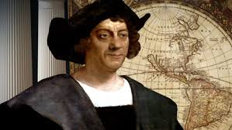  and Neil Armstrong  
English | 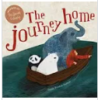  Writing a persuasive letter | 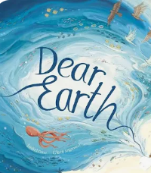  Descritions |  | Geography |  | 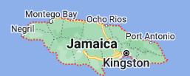  Jamaica
 |  |  |  | Design and Technology | D.T  Textiles - Pouches
Spelling | Prefixes -un -re- under | Suffix- - est-er—ly -ful |  | Music | Orchestral instruments  (Theme: Traditional Western stories) | West African call and response song (Theme: Animals)
Maths | Division and Fractions | Measurements |  | Art |  | Art Sculpture: 3D Clay Houses  Ranti Bam
Science | Plants – Bulbs and Seeds | Plants – Bulbs and Seeds |  | RE | How do some  people talk to God? | Where do some  people talk to God?
Computing | iBlog  Touchtyping | iPublish  Touchtyping |  | PSHE | Health and Wellbeing- How do we recognise our feelings? | RSE Differences
PE | Athletics | Net and Wall |  | MfL | Kapow | Kapow

