 | Summer 1 | Summer 2 |  |  | Summer 1 | Summer 2
Big question | How did the Roman Empire grow and what was their impact on Britain? | How are mountains and volcanoes formed and what is it like to live near Mount Vesuvius? |  | History | The Romans
Visits, visitors and experiences | Roman Day |  |  | Geography |  | Volcanoes
English | Escape from Pompeii  Diary Entry  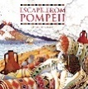  Performance Poetry | The promise  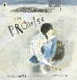  Myths and Legends  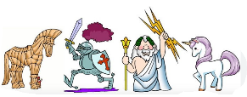  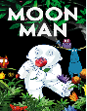  Moon Man |  | Design and Technology |  | Healthy snacks
Whole Class Reading | 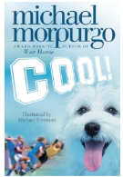  Michael Morpurgo | 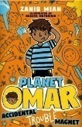  Planet Omar: Accidental Trouble Magnet |  | Music | Adapting and transposing motifs – Theme: The Romans
Maths | Measurement  Fractions  Money | Time  Shape  Statistics |  | Art | 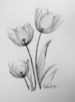  Growing Artists: Drawing and shading
Science | Plants | Animals including Humans |  | RE | Why is water symbolic? Christian, Sikh, Muslim and Shinto. | Why is fire used ceremonially? Hindu/Sikh
Computing | iConnect -  The Internet and World Wide Web | iPodcast -  Creating and editing audio podcasts |  | PSHE | Money and Budgeting | Healthy Lifestyles  RSE
PE | Athletics  Tennis | Golf  Cricket |  | MfL | French transport | French animals and their habitats

